**3 DVD (DIGITAL VERSATILE DISC)**

1. **Technology used in DVD**

13“The digital data (the binary language of ones and zeroes common to all computers) used in DVDs is encoded onto a master disc. This disc is then used to create copies of itself. A laser (a device used to create a narrow, intense beam of very bright light) burns small holes, called pits, into a microscopic layer of metal, usually aluminium. These pits correspond to the binary ones; smooth areas of the disc untouched by the laser, called land, correspond to the binary zeroes. Once the pits have been burned, the metal is coated with a protective, transparent layer.”

1. **Largest capacity available in DVD**

The largest capacity of the DVD depends on what type of DVD it is.

* 14DVD 5 which is otherwise called as single sided single layered has capacity of 5.315e+9 bytes(4.95 GB)
* DVD 10 which is called as doubled sided single layered can hold data up to 9.3952e+9 bytes(8.95 GB)
* DVD 9 also called as Single sided dual layered can hold data up to 8.5362e+9 bytes (7.95)
* DVD 18 also called as double sided dual layered has capacity of 1.92737e+10 bytes (17.95 GB)

1. **Physical structure of DVD**

15

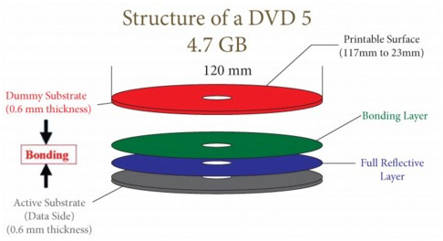

* 16“Each layer of a DVD disc contains lead-in, data area and lead-out like a CD. For dual layer (DVD-9) discs the two layers comprise a single volume, but can be organised in two different ways depending on the application:
* Parallel Track Path (PTP), where the two layers both start at the inside diameter (ID) and end at the outside diameter OD with the lead-out.
* Opposite Track Path (OTP), where layer 0 starts at the ID and layer 1 starts where layer 0 ends. For such discs there is one lead-in (on layer 0), one lead-out (on layer 1) and two middle areas. This is suitable for DVD-Video where a single movie can occupy both layers with a layer break in the middle. Using OTP allows a near seamless jump from layer 0 to layer 1.”

1. **Logical structure of DVD**

* 17A DVD disc always contains a logical volume. For the multi-layer DVD disc, the volume is divided into layers corresponding to the partition. A logical sector which has 2048 bytes is nothing but a logical volume inside the basic logic unit.
* 17“Volume mainly consists a volume and file structure, DVD-Video zone and non-DVD-Video zone (the area is optional), the video files on DVD-Video zone, computer data on non-DVD-Video zone, so you can a DVD disc with video stored on the computer programs and computer games.”

1. **Power Requirements:**

Normally DVD consumes about 25 Watts of power during burning.